Nathan Burlison
CS 305 Module Two Coding Assignment
Sept. 12, 2026

1. Run Dependency Check
I ran OWASP Dependency-Check 13.0.0 on the Module2.2 project. The scan checked 38 dependencies, including 20 unique ones, and flagged 10 dependencies with possible security issues. Altogether, the report listed 248 vulnerability matches and 0 suppressed findings. These results are useful, but they are only a starting point. Dependency-Check connects package information to CPE records and related CVEs, so each match still needs to be reviewed to make sure it actually applies to the version and setup used in the project (OWASP Foundation, n.d.-a).

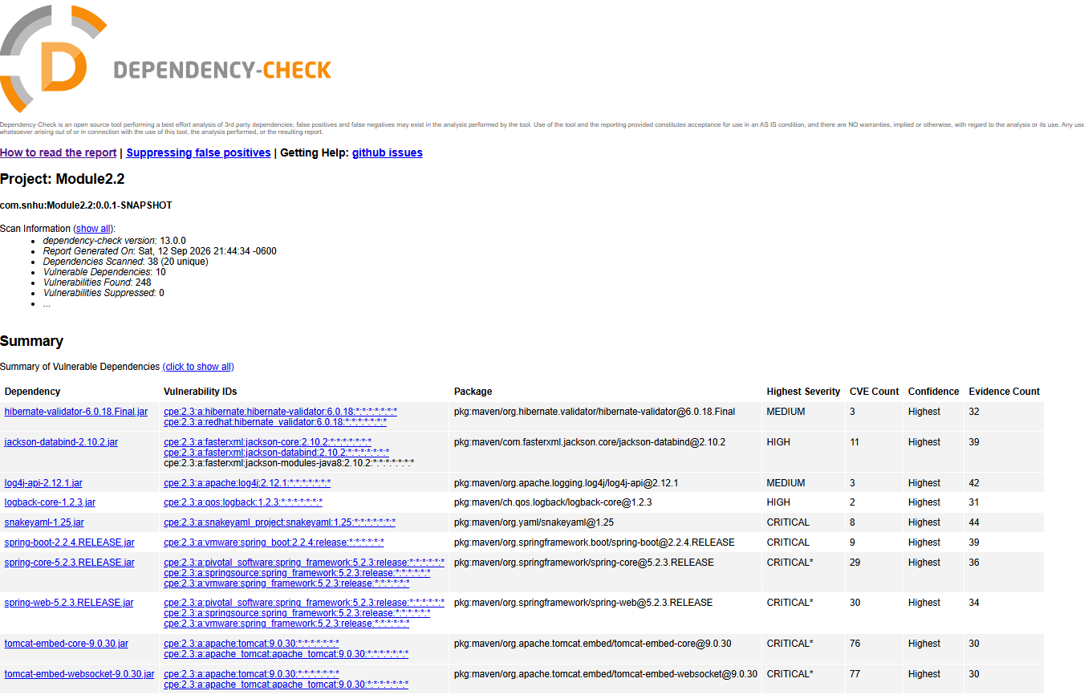
Figure 1. OWASP Dependency-Check HTML summary for Module2.2.

2. Document Results
The table below lists the 10 dependencies flagged in the HTML report, along with the package/CPE code, highest severity, CVE count, and a short description. The full HTML report can be used to review each individual CVE match.
Dependency | Code / Identifier | Severity / CVEs | Description / Security Relevance
hibernate-validator 6.0.18.Final | pkg:maven/org.hibernate.validator/hibernate-validator@6.0.18.Final  CPE: hibernate/redhat:hibernate-validator | MEDIUM  3 | Bean Validation library; verify that the reported CVEs apply to this exact version.
jackson-databind 2.10.2 | pkg:maven/com.fasterxml.jackson.core/jackson-databind@2.10.2  CPE: fasterxml:jackson-databind | HIGH  11 | JSON data-binding library; older versions have known deserialization risks.
log4j-api 2.12.1 | pkg:maven/org.apache.logging.log4j/log4j-api@2.12.1  CPE: apache:log4j | MEDIUM  3 | Logging API; actual risk depends on the Log4j implementation and configuration.
logback-core 1.2.3 | pkg:maven/ch.qos.logback/logback-core@1.2.3  CPE: qos:logback | HIGH  2 | Core Logback library; update it together with the matching logging components.
snakeyaml 1.25 | pkg:maven/org.yaml/snakeyaml@1.25  CPE: snakeyaml_project:snakeyaml | CRITICAL  8 | YAML parser; older versions include unsafe parsing and denial-of-service risks.
spring-boot 2.2.4.RELEASE | pkg:maven/org.springframework.boot/spring-boot@2.2.4.RELEASE  CPE: vmware:spring_boot | CRITICAL  9 | Spring Boot framework; upgrading it refreshes many managed dependencies at once.
spring-core 5.2.3.RELEASE | pkg:maven/org.springframework/spring-core@5.2.3.RELEASE  CPE: spring_framework:5.2.3 | CRITICAL*  29 | Core Spring library; check each CVE against the exact affected version and setup.
spring-web 5.2.3.RELEASE | pkg:maven/org.springframework/spring-web@5.2.3.RELEASE  CPE: spring_framework:5.2.3 | CRITICAL*  30 | Spring web/HTTP library; upgrade through Spring Boot and retest web behavior.
tomcat-embed-core 9.0.30 | pkg:maven/org.apache.tomcat.embed/tomcat-embed-core@9.0.30  CPE: apache:tomcat:9.0.30 | CRITICAL*  76 | Embedded Tomcat server; older versions include request-processing and DoS risks.
tomcat-embed-websocket 9.0.30 | pkg:maven/org.apache.tomcat.embed/tomcat-embed-websocket@9.0.30  CPE: apache:tomcat:9.0.30 | CRITICAL*  77 | Tomcat WebSocket component; keep it on the same patched version as Tomcat core.

3. Analyze Results
The main fix I would make is upgrading the project from Spring Boot 2.2.4.RELEASE to a supported version that still works with the application. That is a better approach than trying to update every old JAR by hand because Spring Boot manages compatible versions of Spring Framework, Tomcat, Jackson, SnakeYAML, and the logging libraries together. After the upgrade, I would run the unit and integration tests, run Dependency-Check again, and then review any high or critical findings that are still left. Those remaining findings should be checked in the NVD to see whether the exact version and conditions apply to this application. For example, the NVD shows that Apache Tomcat 9.0.30 falls within the affected range for CVE-2020-1935, which involves HTTP request smuggling under certain proxy configurations (National Institute of Standards and Technology [NIST], 2020).
It is also important to review false positives instead of treating every alert as a confirmed vulnerability. A scan can sometimes match a dependency to the wrong product record or flag a CVE that cannot actually be exploited in the way the application is configured. I would first confirm that the CPE really matches the dependency, then check whether the reported CVE applies to the exact version and how the application uses it. If a finding is confirmed to be a false positive, it can be documented in a suppression XML file so future scans stay focused on issues that actually need attention (OWASP Foundation, n.d.-a, n.d.-b). Because CPE names are used by the NVD to connect products with CVEs, checking that match is an important part of the review process (NIST, n.d.). Any suppression should include a reason and should be reviewed again after dependencies are upgraded rather than being left in place forever.

References
National Institute of Standards and Technology. (n.d.). CPE FAQs. National Vulnerability Database. https://nvd.nist.gov/general/faq-sections/cpe-faqs
National Institute of Standards and Technology. (2020). CVE-2020-1935. National Vulnerability Database. https://nvd.nist.gov/vuln/detail/CVE-2020-1935
OWASP Foundation. (n.d.-a). How to read the reports. OWASP Dependency-Check. https://dependency-check.github.io/DependencyCheck/general/thereport.html
OWASP Foundation. (n.d.-b). Suppressing false positives. OWASP Dependency-Check. https://dependency-check.github.io/DependencyCheck/general/suppression.html

